UNIT-II

MEASUREMENT OF POWER AND ENERGY

**2.1 Single phase Dynamo meter type watt meter :** In general, a watt meter is used to measure the electric power of a circuit, or sometime it also measures the rate of energy transferred from one circuit to another circuit. When a moving coil (that is free to rotate) is kept under the influence of a current carrying conductor, then automatically a mechanical force will be applied to the moving coil, and this force will make a little deflection of the moving coil. If a pointer is connected with the moving coil, which will move of a scale, then the deflection can be easily measured by connecting the moving coil with that pointer. This is the principle of operation of all dynamo meter type instruments, and this principle is equally applicable for dynamo meter type watt meter also.

This type of watt meter consists of two types of coil, more specifically current coil and voltage coil. There are two current coils which are kept at constant position and the measurable current will flow through those current coils. A voltage coil is placed inside those two current coils, and this voltage coil is totally free to rotate. The current coils are arranged such a way, that they are connected with the circuit in series. And the voltage coil is connected in parallel with the circuit.

As simple as other voltmeter and ammeter connection. In fact, a watt meter is a package of an ammeter and a voltmeter, because the product of voltage and current is the power, which is the measurable quantity of a watt meter.

When current flows through the current coils, then automatically a magnetic field is developed around those coils. Under the influence of the electromagnetic field, voltage coil also carries some amount of current as it is connected with the circuit in parallel. In this way, the deflection of the pointer will proportional to both current and voltage of the circuit. In this way, Watt = Current × Voltage equation is satisfied and the deflection shows the value of power inside the circuit. A dynamo meter type watt meter is used in various applications where the power or energy transfer has to be measured.

Construction and Working Principle of Electrodynamometer Type Wattmeter

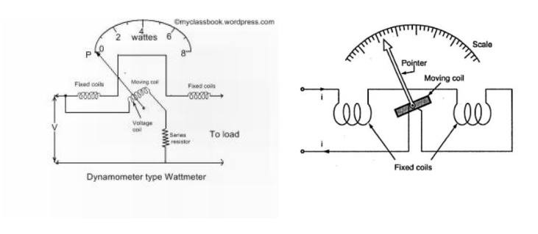

Now let us look at constructional details of electrodynamometer. It consists of following parts There are two types of coils present in the electrodynamometer.They are :

(a) Moving coil : Moving coil moves the pointer with the help of spring control instrument. A limited amount of current flows through the moving coil so as to avoid heating. So in order to limit the current we have connect the high value resistor in series with the moving coil. The moving coil is air cored and is mounted on a pivoted spindle and can moves freely. In electrodynamometer type wattmeter, moving coil works as pressure coil. Hence moving coil is connected across the voltage and thus the current flowing through this coil is always proportional to the voltage.

 (b) Fixed coil: The fixed coil is divided into two equal parts and these are connected in series with the load, therefore the load current will flow through these coils. Now the reason is very obvious of using two fixed coils instead of one, so that it can be constructed to carry considerable amount of electric current. These coils are called the current coils of electrodynamometer type wattmeter. Earlier these fixed coils are designed to carry the current of about 100 amperes but now the modern wattmeter are designed to carry current of about 20 amperes in order to save power.

(c) Control system: Out of two controlling systems i.e.

(1). Gravity control  (2) Spring control,

only spring controlled systems are used in these types of wattmeter. Gravity controlled system cannot be employed because they will appreciable amount of errors.

(d) Damping system: Air friction damping is used, as eddy current damping will distort the weak operating magnetic field and thus it may leads to error.

(e) Scale: There is uniform scale is used in these types of instrument as moving coil moves linearly over a range of 40 degrees to 50 degrees on either sides.

Now let us derive the expressions for the controlling torque and deflecting torques. In order to derive these expressions let us consider the circuit diagram given below:

We know that instantaneous torque in electro dynamic type instruments is directly proportional to product of instantaneous values of currents flowing through both the coils and the rate of change of flux linked with the circuit.

Let Ip.c and Ic be the instantaneous values of currents in pressure and current coils respectively. So the expression for the torque can be written as:



 Advantages of Electrodynamometer Type Wattmeter

Following are the advantages of electrodynamometer type wattmeters and they are written as follows:

(a). Scale is uniform up to certain limit

(b). They can be used for both to measure AC as well as DC quantities as scale is calibrated for both.

**2.2 Errors in Electrodynamometer Type Wattmeter**

Following are the errors in the electrodynamometer type wattmeter:

**Error Due to pressure coil Inductance:**

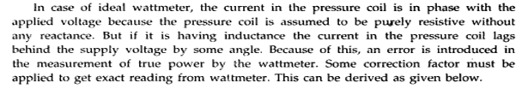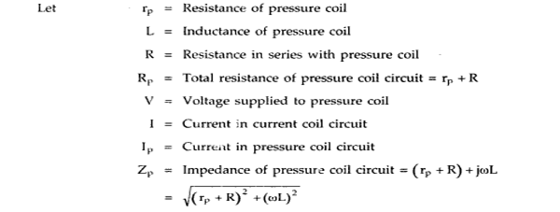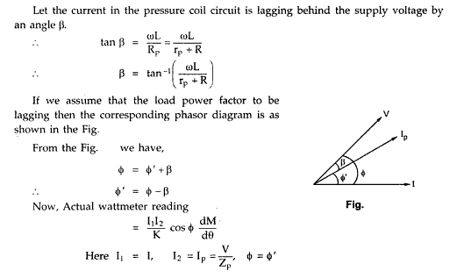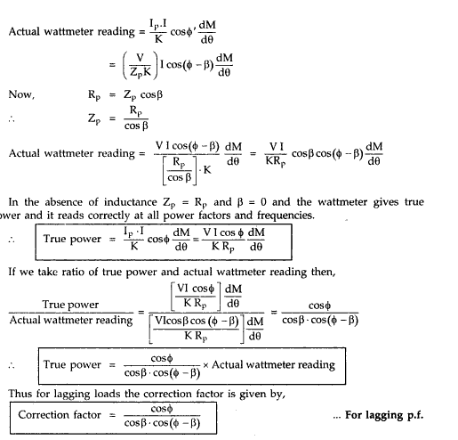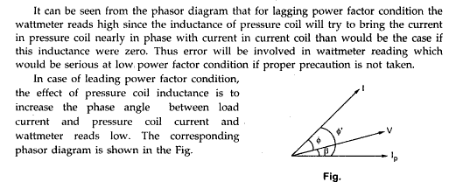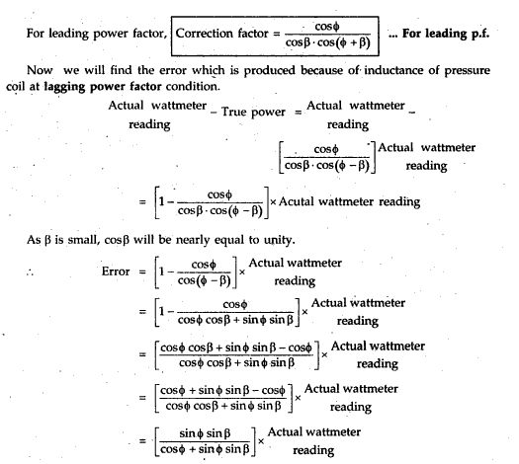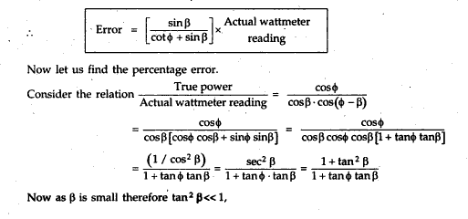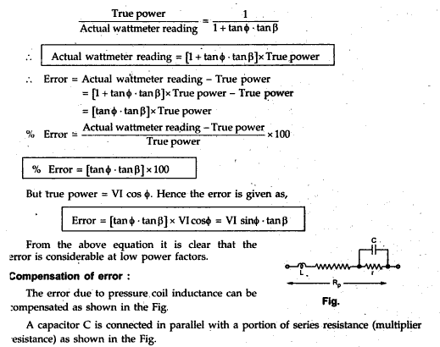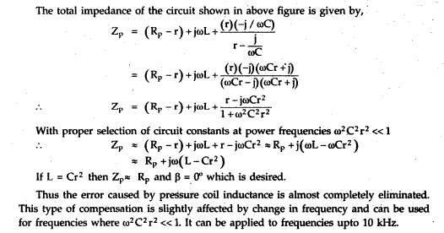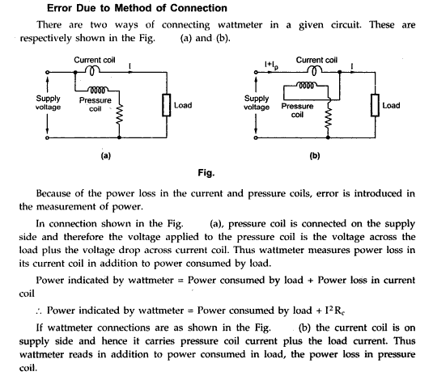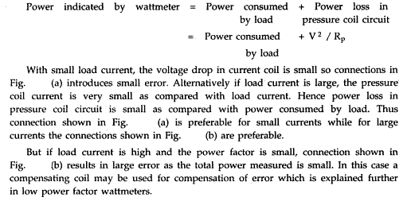

**Error due to Pressure coil capacitance:** The pressure coil circuit may have capacitance in addition with inductance. This capacitance mainly due to the inter turn capacitance of the series resistance. The effect of capacitance is opposite to that due to inductance. Therefore the wattmeter will read high when the load power factor is leading. The inductance in pressure coil circuit will always more than inductance, hence the error caused by capacitance will be nullified by that due to inductance.

**Error due to mutual inductance**: Errors may occur due to the mutual inductance between the current and pressure coils of the watt meter. These errors are quite low at power frequencies. But they increased with increase in frequencies. The effect of mutual inductance can be avoided by arranging the coil system in such a way that they have no mutual inductance. So we can eliminate the errors due to mutual inductance. The Drysdale Torsion head wattmeter is an example for such type.

**Eddy Current errors:** Eddy currents are induced in the solid metal parts and within the thick conductors by the alternating magnetic field produced by the current coil. This eddy currents produce their own magnetic field and it will alter that produced by the main current in the current coil and thus error occurred. This error can be minimized by avoiding solid metal parts as much as possible and by using 32 stranded conductors for high current applications.

**Stray Magnetic field Errors:** The electrodynamometer type wattmeter has a weak operating field and therefore it is affected by stray magnetic fields it will result in serious errors. Hence these instruments should be shielded against stray magnetic field.

**Errors caused by vibration of moving system:** The torque on the moving system varies with frequency which is twice that of voltage. If the parts of the moving system have a natural frequency which is resonance with the frequency of torque pulsation, the moving system would vibrate with considerable amplitude. These vibrations will cause errors. This error can be reduced by design.

Temperature Error: The change in room temperature may affect the indication of wattmeter. This is because of change in temperature will change in resistance of pressure coil and stiffness of springs which provide controlling torque. This effect are opposite in nature and cancel each other. The use of material of having negligible temperature coefficient of resistance will reduce change in resistance the pressure coils with change in temperature.

**2.3 Blondel's theorem:**

The theorem states that the power provided to a system of N conductors is equal to the algebraic sum of the power measured by N watt-meters. The N watt-meters are separately connected such that each one measures the current level in one of the N conductors and the potential level between that conductor and a common point. In a further simplification, if that common point is located on one of the conductors, that conductor's meter can be removed and only N-1 meters are required.

2.3.1 Two Wattmeter Method – Balanced Load Condition

The Two Wattmeter Method is explained, taking an example of a balanced load. In this, we have to prove that the power measured by the Two Wattmeter i.e. the sum of the two wattmeter readings is equal to root 3 times of the phase voltage and line voltage (√3VLIL Cosϕ) which is the actual power consumed in a 3 phase balanced load.

The connection diagram of a 3 phase balanced load connected as Star Connection is shown below.

[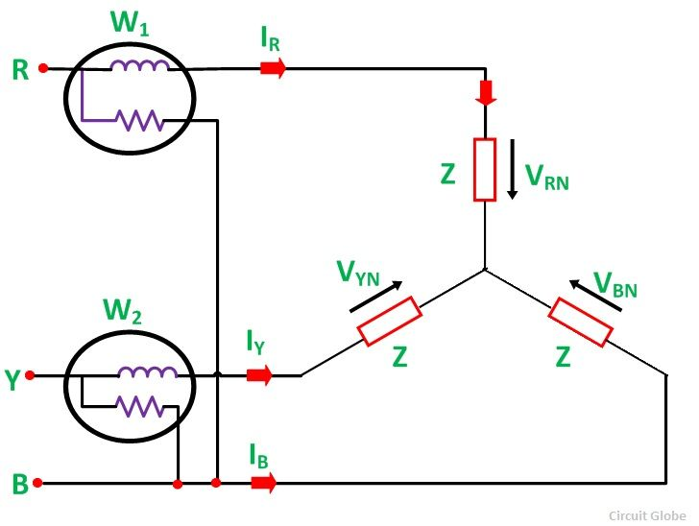](http://circuitglobe.com/wp-content/uploads/2015/11/TWO-WATTMETER-METHOD-BALANCED-LOAD-FIG-1-compressor.jpg)

Contents:

* [Determination of Power Factor from Wattmeter Readings](http://circuitglobe.com/two-wattmeter-method-balanced-load-condition.html#DeterminationofPowerFactorfromWattmeterReadings)
* [Determination of Reactive Power by Two Wattmeter Method](http://circuitglobe.com/two-wattmeter-method-balanced-load-condition.html#DeterminationofReactivePowerbyTwoWattmeterMethod)

The load is considered as an inductive load, and thus, the phasor diagram of the inductive load is

drawn below.[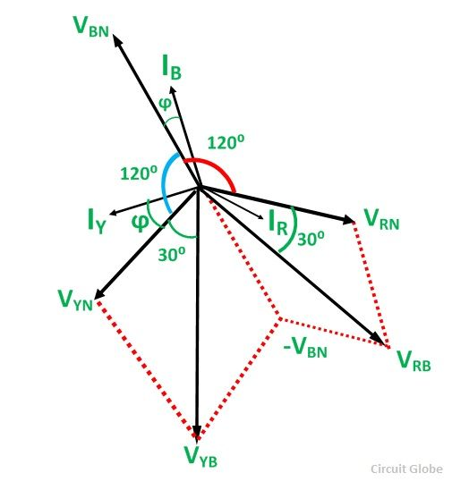](http://circuitglobe.com/wp-content/uploads/2015/11/TWO-WATTMETER-METHOD-BALANCED-LOAD-FIG-2-compressor.jpg)

The three voltages VRN, VYN and VBN, are displaced by an angle of 120 degrees electrical as shown in the phasor diagram. The phase current lag behind their respective phase voltages by an angle ϕ.

Now, the current flowing through the current coil of the Wattmeter, W1 will be given as

[two-wattmeter-balance-condition-eq1](http://circuitglobe.com/wp-content/uploads/2015/11/two-wattmeter-balance-condition-eq1-compressor.jpg)

Potential difference across the pressure or potential coil of the Wattmeter, W1 will be

[two-wattmeter-balance-condition-eq2](http://circuitglobe.com/wp-content/uploads/2015/11/two-wattmeter-balance-condition-eq2-compressor.jpg)

To obtain the value of VYB, reverse the phasor VBN and add it to the phasor VYN as shown in the phasor diagram above. The phase difference between VRB and IR is (30⁰ – ϕ)

Therefore, the power measured by the Wattmeter, W1 is

[two-wattmeter-balance-condition-eq3](http://circuitglobe.com/wp-content/uploads/2015/11/two-wattmeter-balance-condition-eq3-compressor.jpg)

Current through the current coil of the Wattmeter, W2 is given as

[two-wattmeter-balance-condition-eq4](http://circuitglobe.com/wp-content/uploads/2015/11/two-wattmeter-balance-condition-eq4jpg-compressor.jpg)

Potential difference across the Wattmeter, W2 is

[two-wattmeter-balance-condition-eq5](http://circuitglobe.com/wp-content/uploads/2015/11/two-wattmeter-balance-condition-eq5jpg-compressor.jpg)

The phase difference VYB and IY is (30⁰ + ϕ).

Therefore, the power measured by the Wattmeter, W2 is given by the equation shown below.

[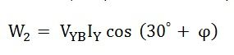](http://circuitglobe.com/wp-content/uploads/2015/11/two-wattmeter-balance-condition-eq6jpg-compressor.jpg)

Since, the load is in balanced condition, hence,

[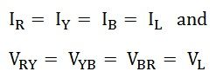](http://circuitglobe.com/wp-content/uploads/2015/11/two-wattmeter-balance-condition-eq7jpg-compressor.jpg)

Therefore, the wattmeter readings will be

[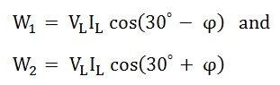](http://circuitglobe.com/wp-content/uploads/2015/11/two-wattmeter-balance-condition-eq8jpg-compressor.jpg)

Now, the sum of two Wattmeter readings will be given as

[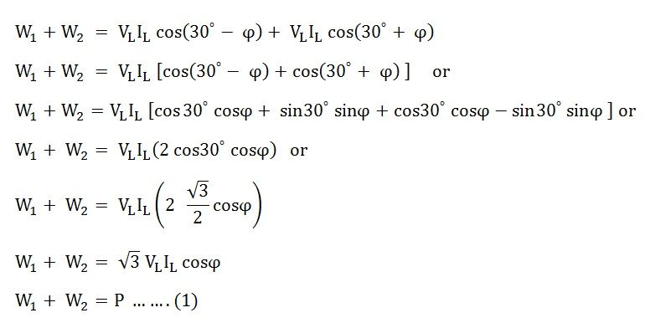](http://circuitglobe.com/wp-content/uploads/2015/11/two-wattmeter-balance-condition-eq9jpg-compressor.jpg)

The above equation (1) gives the total power absorbed by a 3 phase balanced load. Thus, the sum of the readings of the two Wattmeters is equal to the power absorbed in a 3 phase balanced load.  
Determination of Power Factor from Wattmeter Readings

As we know that,

[two-wattmeter-balance-condition-eq10](http://circuitglobe.com/wp-content/uploads/2015/11/two-wattmeter-balance-condition-eq10jpg-compressor.jpg)

Now,

[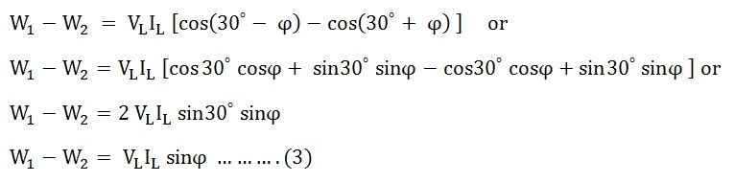](http://circuitglobe.com/wp-content/uploads/2015/11/two-wattmeter-balance-condition-eq11jpg-compressor.jpg)

Dividing equation (3) by equation (2) we get,

[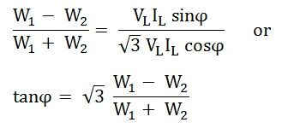](http://circuitglobe.com/wp-content/uploads/2015/11/two-wattmeter-balance-condition-eq12jpg-compressor.jpg)

Power factor of the load is given as

[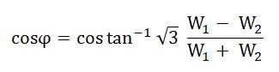](http://circuitglobe.com/wp-content/uploads/2015/11/two-wattmeter-balance-condition-eq13jpg-compressor.jpg)

Determination of Reactive Power by Two Wattmeter Method

To get the reactive power, multiply equation (3) by √3.

[two-wattmeter-balance-condition-eq14](http://circuitglobe.com/wp-content/uploads/2015/11/two-wattmeter-balance-condition-eq14jpg-compressor.jpg)

Therefore, the Reactive Power is given by the equation shown below.

[two-wattmeter-balance-condition-eq15](http://circuitglobe.com/wp-content/uploads/2015/11/two-wattmeter-balance-condition-eq15jpg-compressor.jpg)

**2.4.Extension of Range of Wattmeter using Instrument Transformers:**

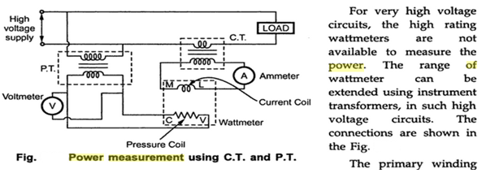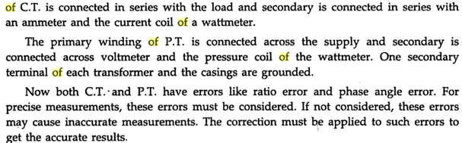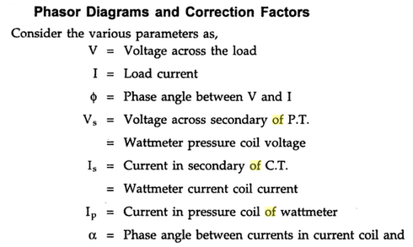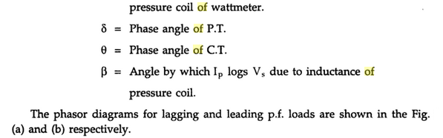  
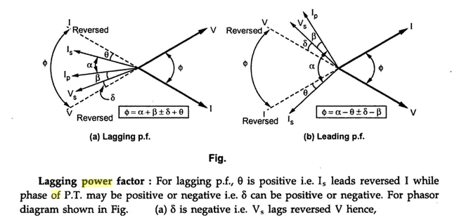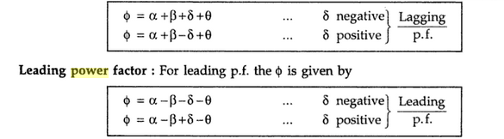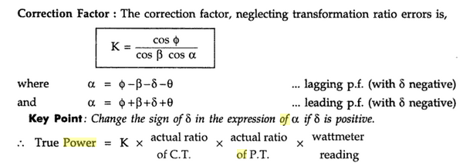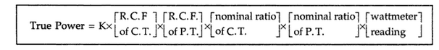

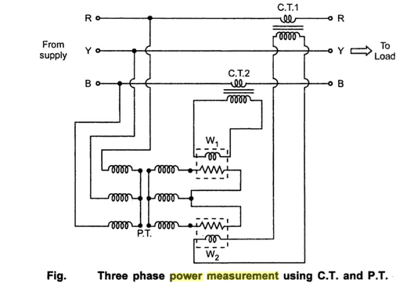

**2.6. Introduction to Energy**

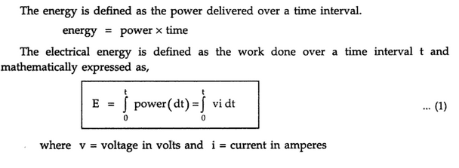

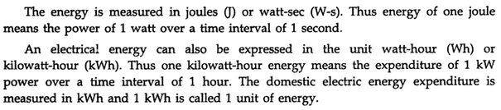

**2.7 Single phase Energy Meter:**

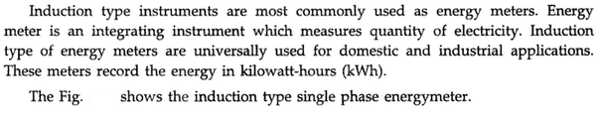

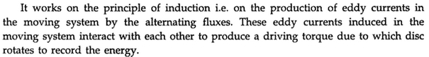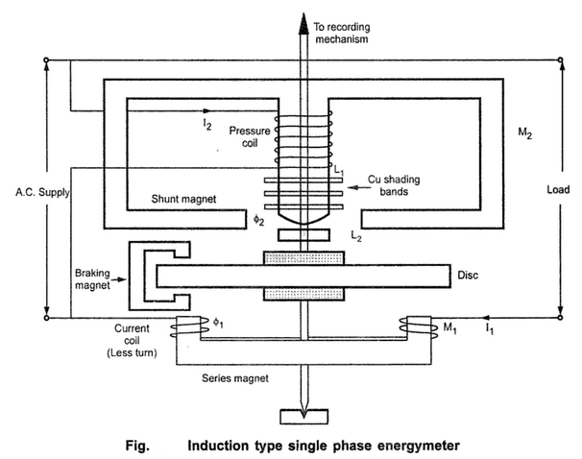



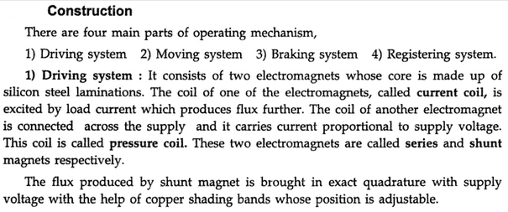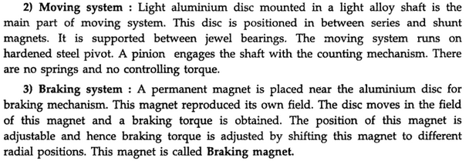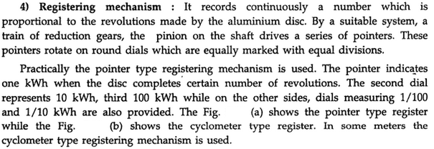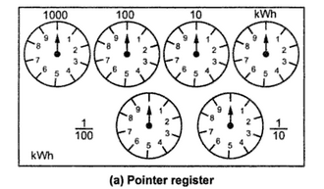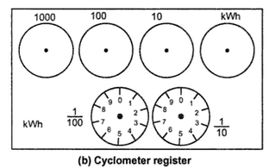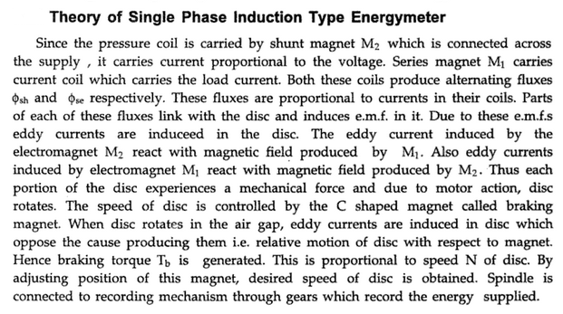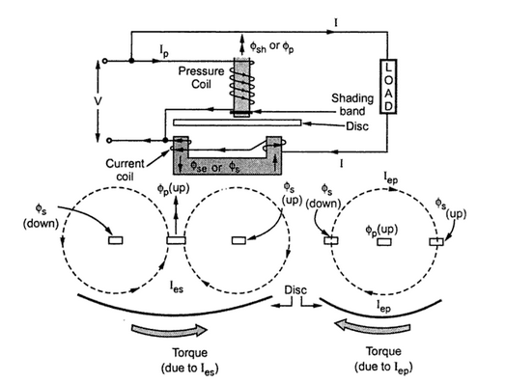****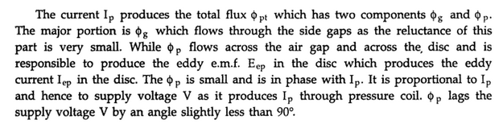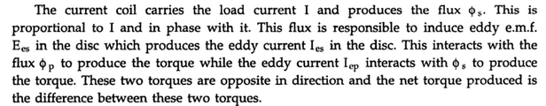**Torque Equation:**

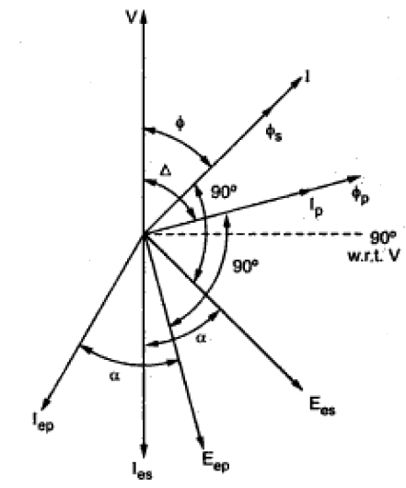

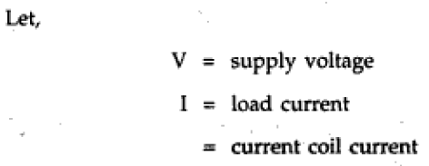

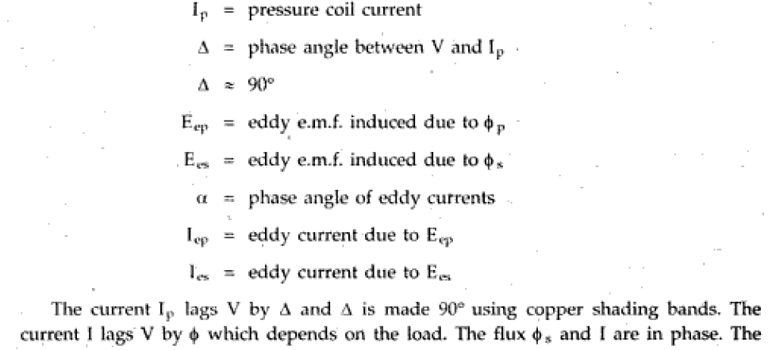

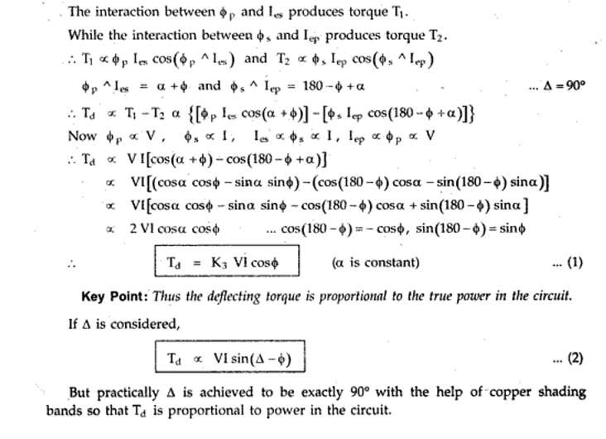

**2.8.Errors and it's Adjustment in Energy Meter:**

Energy meters should give correct readings over a period of several years under normal use conditions. Some of the common errors in energy meter and their remedial measures are discussed below.

1.   **Lag Adjustment or power factor Adjustment or Phase Error:** It is necessary that the energy --meter should give correct reading on all power factors, which is only possible when the field setup by shunt magnet lags behind the applied voltage by 90o. But the flux due to shunt magnet does not lag behind the applied voltage exactly by 90o because of winding resistance and iron losses.

**Adjustment:** The flux in the shunt magnet can be made to lag behind the supply voltage by exactly 90o by adjusting the position of shading band (or shading ring or shading coil) placed round the lower part of the control limb of the shunt magnet. These bands are adjustable. By moving these bands along the axis of the central limb, the lag adjustment can be achieved. When bands are moved upwards, the e.m.f induced in them increases increasing the m.m.f produced, hence lag angle increases. When bands are moved down, the m.m.f produced by the bands decreases which decreases the lag angle. Thus the shunt magnet flux can be brought in exact quadrature with the voltage V. This adjustment is known as *lag adjustment* or *power factor adjustment* (or *power factor compensator*).

2.    **Speed Error:** Sometimes the speed of the meter is either fast or slow, resulting in the wrong recording of energy consumption.

**Adjustment:** An error in the speed of the meter when tested on non-inductive load can be eliminated by correctly adjusting the position of the brake magnet. Movement of the brake magnet in the direction of the spindle will reduce the braking torque and vice-versa.

3.  **Creeping:** Sometimes the disc of the energy meter makes slow but continuous rotation at no load i.e. when the potential coil is excited but with no current flowing in the load. This is called creeping. This error may be caused due to over compensation for friction, excessive supply voltage, vibrations, stray magnetic fields etc.

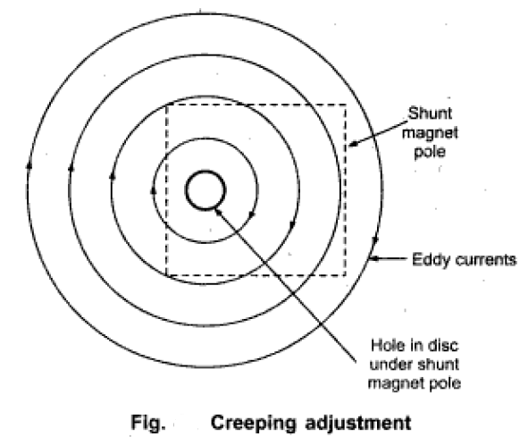

**Adjustment:** In order to prevent this creeping on no load, two holes or slots are drilled in the disc on opposite side. When the hole comes under the shunt magnet pole, it gets acted upon by a torque opposite to its rotation. This is shown in fig.

when a hole comes under the shunt magnet, the circular eddy current paths in the disc get distorted. This distortion is responsible to produce torque in opposite direction to the rotation of the disc. This stops creeping. The torque is not very large so as to cause errors under normal operating conditions.





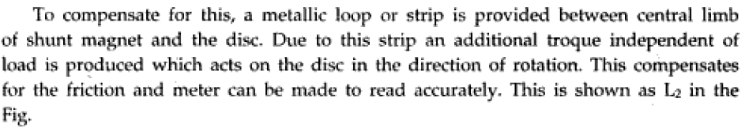

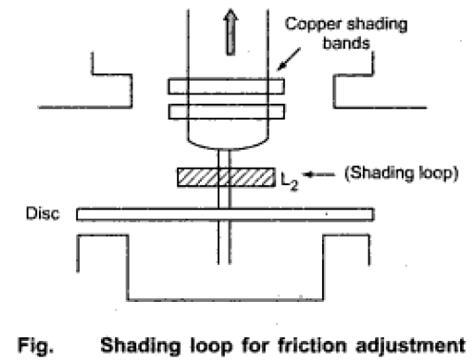

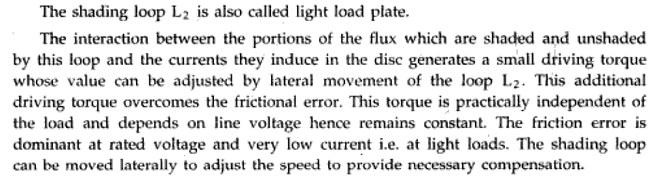

5. **Temperature compensation:**

As temperature increases the resistance of the copper and aluminium parts increases. This has following effects.

(i) Small reduction in shunt magnet flux

(ii) Reduction on phase angle of lag between V and shunt magnet flux

(iii) Reduction in torque produced by all shading bands

(iv) Increase in eddy current resistance path.

These various effects neutralize each other and hence errors due to temperature are not serious. But at low lagging power factor loads, such effects may cause serious errors. These effects are compensated by providing a temperature shunt on the brake magnet. Special magnetic materials such as Mutemp is used for the shunt whose permeability decreases considerably as temperature increases. This provides temperature compensation and does not allow the disc to rotate faster as temperature increases.

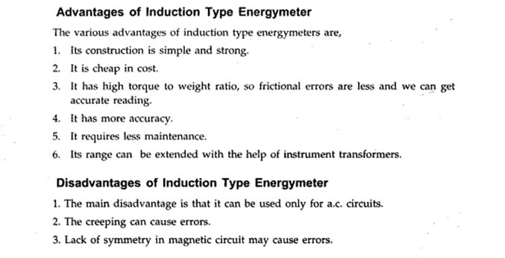

**2.9. Phantom Loading:**

When a energy meter is designed for high current loads, it is uneconomical to arrange such loads for testing purposes as it involves a considerable waste of time and power. To avoid this problem “phantom” or “fictitious” loading is done. In phantom loading, pressure coil is excited from normal supply voltage and current coil is excited from a separate low voltage supply. The low impedance of current coil circuit makes it possible to circulate the required current even with low supply voltage. Then total power supplied for the test is sum of power supplied to small pressure coil current at normal voltage and due to rated current at very low voltage. Thus the overall power loss during test is very small

.

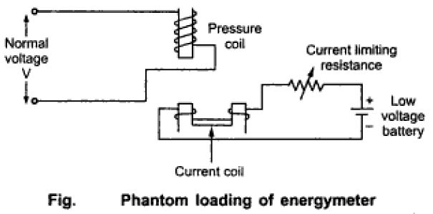

**2.10. Three Phase Energy Meter:**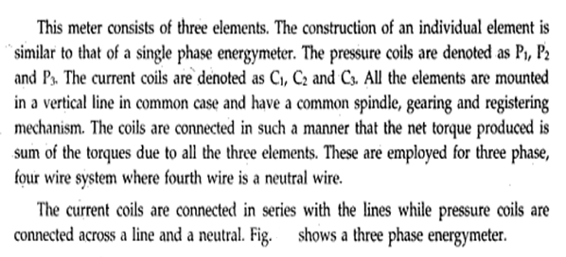

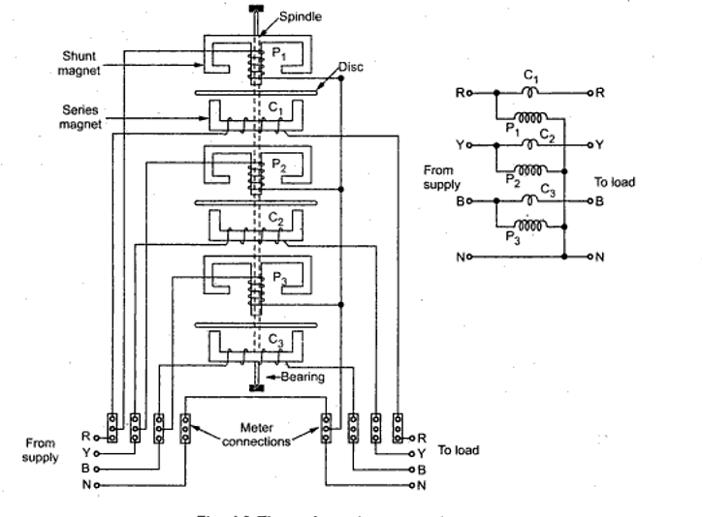

Fig. Three element energy meter

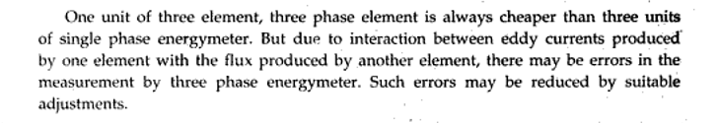

**2.11. Two Element Energy meter:**

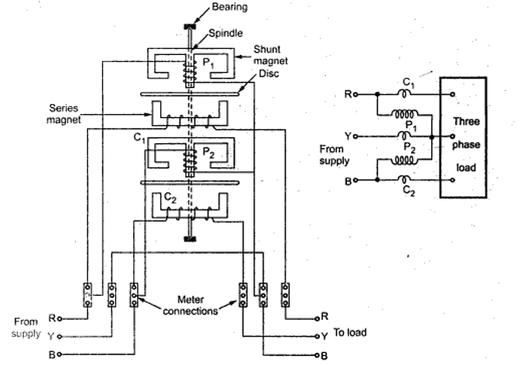

Fig. Two element energy meter

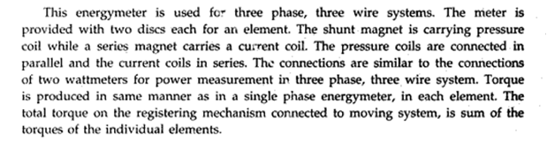

**2.11. Trivector Meter:**

The Trivector meter is a measuring instrument which measures the kW, kVAr, the kVA of a power line.  These instruments can measure both power as well as energy.    Trivector meters are normally used in substations and to measure the power flowing through the feeders.  They are used for billing power drawn by industrial customers.  The Trivector enables the simultaneous measurement of different electrical parameters which enables accurate assessment of the power consumed.    
 Trivector is called so as it measures three vectors representing the active, reactive and apparent power of a line.  Trivector meters come in two quadrant and four quadrant models.  The four quadrant model can measure both the incoming (import) and the outgoing power (export) while the two quandrant trivector meter can measure either imported or exported power.  
  
 In earlier days, the Electromechanical trivector meters were used.  Today, though, almost all Trivector meters are of the static type.  Modern Trivector meters can measure many parameters apart from the active, reactive and apparent power.